Foundations of Robotics

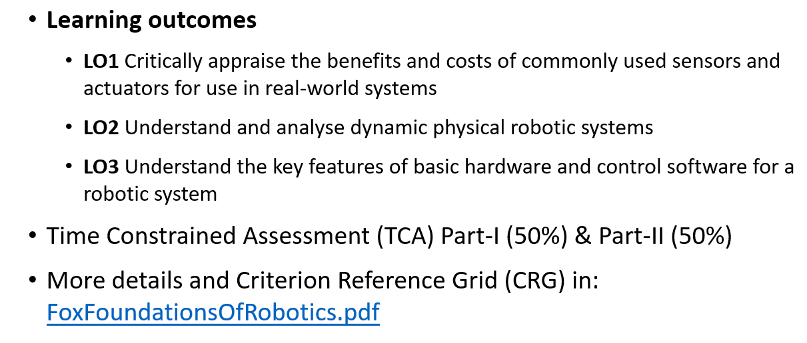

What is a robot?

A machine that can intelligently perform a complicated series of tasks by itself

How can we differentiate between an automaton and a robot?

* Capability to perform complex series of actions intelligently
* Sensors help robot to perceive the environment state and perform these complex actions intelligently
* Most automata don’t have sensors and cannot adapt their actions to new situations

Classification – based on environment

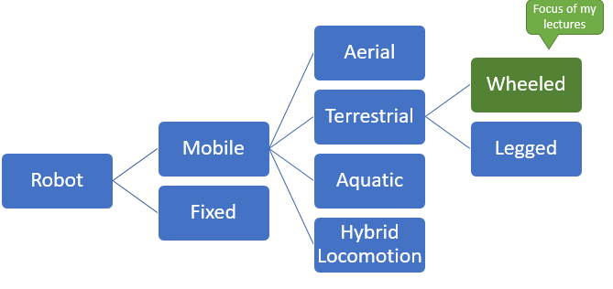

Overview – What will be covered in Gautham’s lectures

Robot motion and odometry

Control Systems

Local navigation – obstacle avoidance

Introduction to localisation

Environment mapping

Multi-robot systems

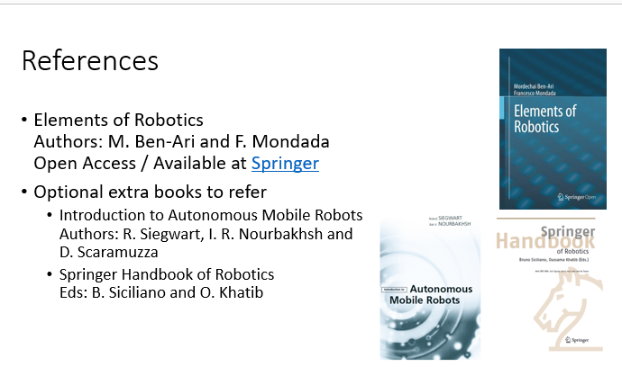

Challenge with Mobile Robots

Localisation

Knowing where to go

Deciding how to get there

